Big Data Management and Analytics Lab

Lab Exercise 01: Install Cloudera on VirtualBox in Windows

NAME : ANNAPOORNIMA S

ROLL NO : 225229101

BDMA EXERCISE -1

Step 1:

Download VirtualBox for Windows:

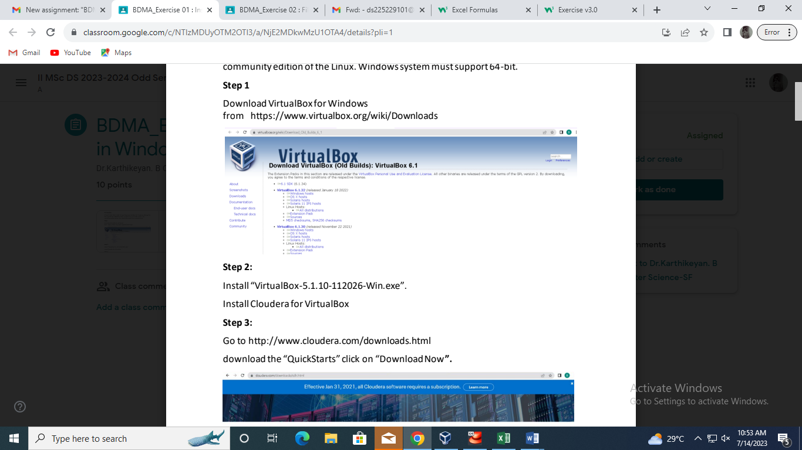

Step 2:

Install “VirtualBox-5.1.10-112026-Win.exe”

Step 3:

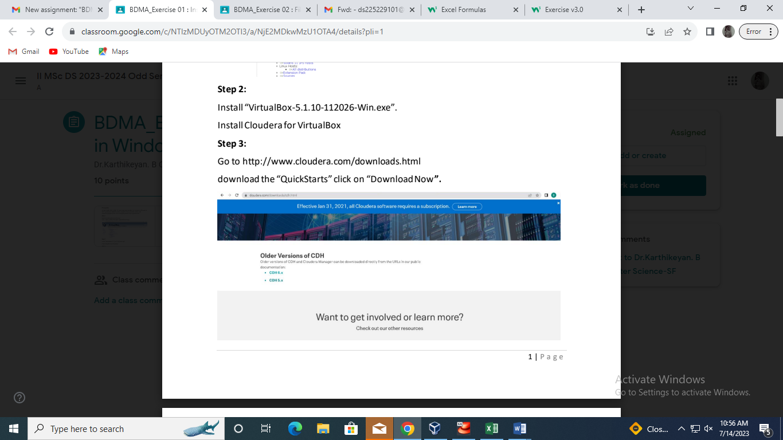

Step 4:

Extract the download “Cloudera-quickstart-VM-5.8.0-0-virtualbox.zip”. The extracted

zip should have the “Cloudera-quickstart-VM-5.8.0-0-Virtualbox-disk1.vmdk“.

Configure Virtual Box And Cloudera

Step 5:

Open the VirtualBox, and create a new VM.

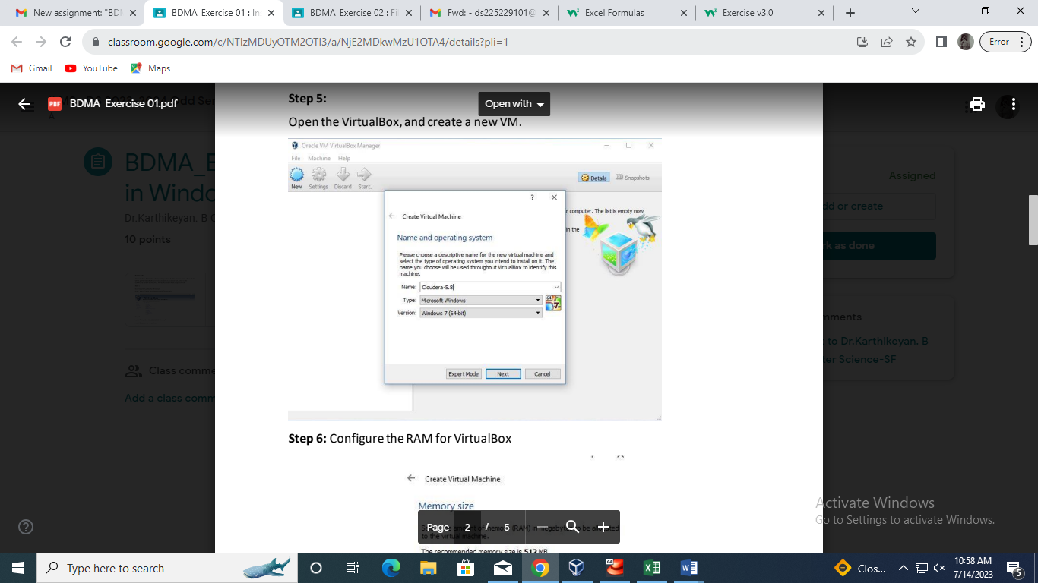

Step 6:

Configure the RAM for VirtualBox

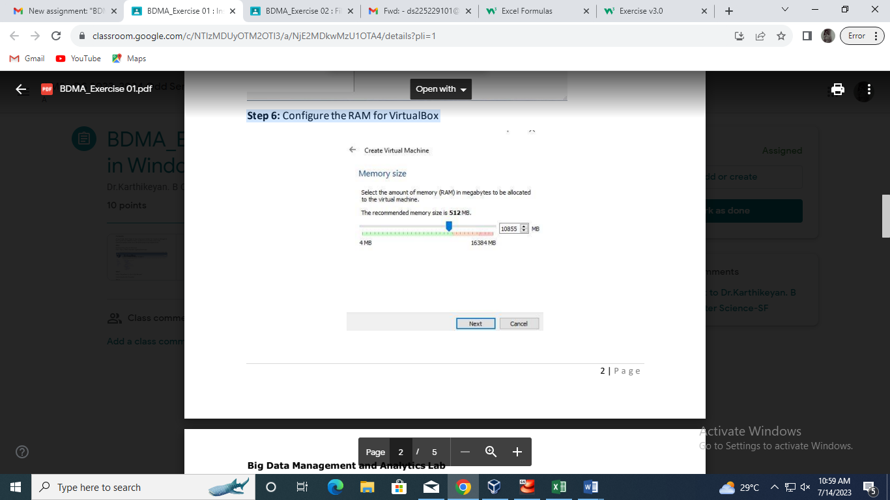

Step 7:

Add the Cloudera “Cloudera-quickstart-VM-5.8.0-0-Virtualbox-disk1.vmdk” that was

previously downloaded and extracted

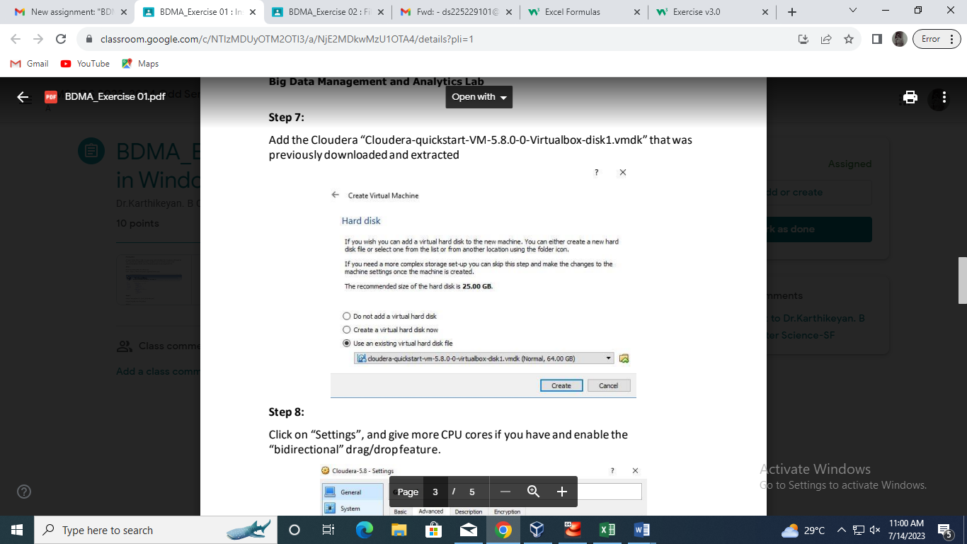

Step 8:

Click on “Settings”, and give more CPU cores if you have and enable the

“bidirectional” drag/drop feature.

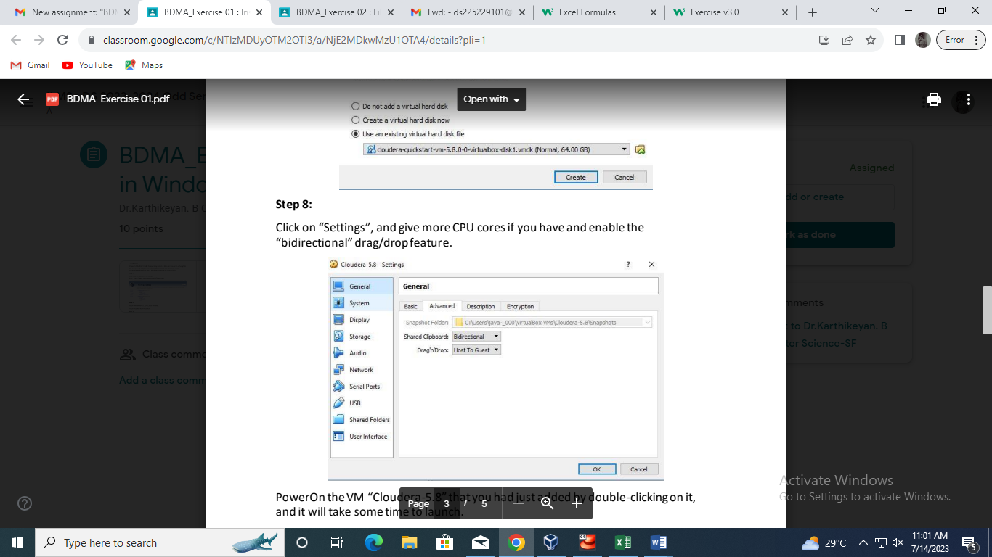

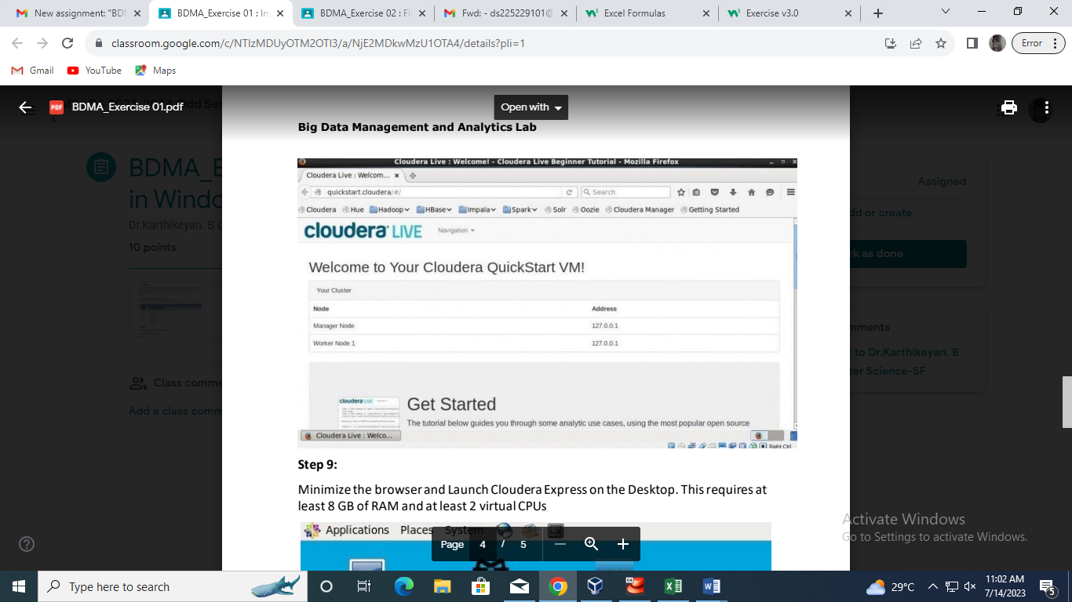

Step 9:

Minimize the browser and Launch Cloudera Express on the Desktop. This requires at

least 8 GB of RAM and at least 2 virtual CPUs

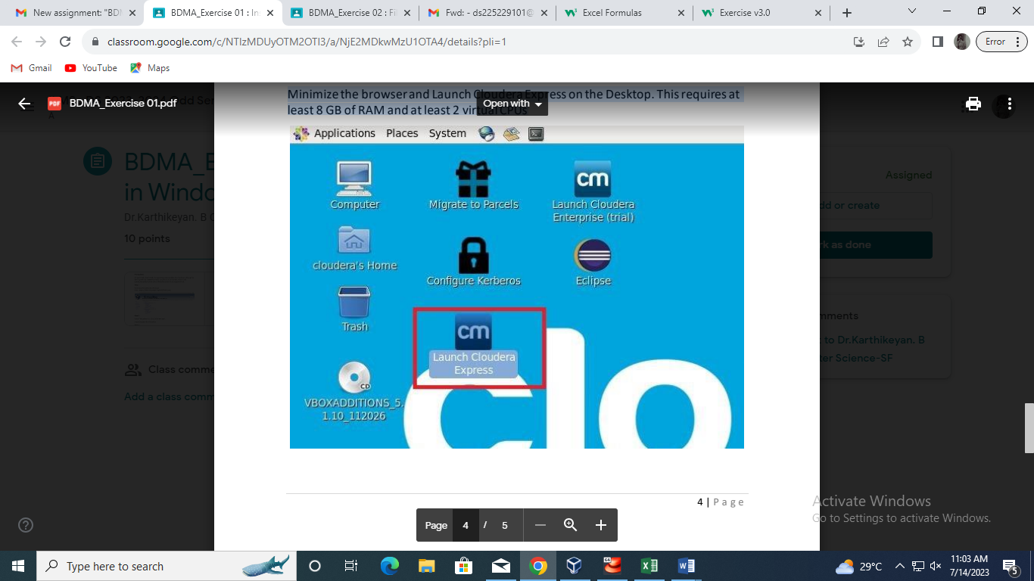

**Step 10:**

It will take some time to start as per the system configuration that you have set.

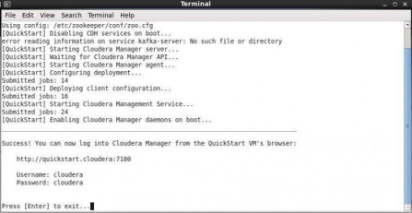

**Step 11:**

Make sure that the relevant services are started, and if not start them as per the use.

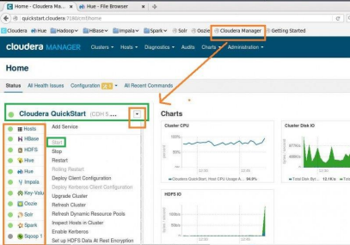5 |